OSSP (Operating Systems and Systems Programming) – 25CS2104E
OSSP LAB – SKILL-1

Aim
To set up a Linux development environment by installing a Linux VM, configuring GCC, creating a Git repository, organizing the project structure, understanding shell architecture, and building an initial Makefile, and to analyze process abstraction by executing fork(), understanding the exec() family, studying parent-child relationships, inspecting the process tree, and practicing system-call tracing.

Algorithm
- Install and configure the Linux virtual machine.
- Install and verify the GCC compiler.
- Create a project directory with an appropriate structure.
- Initialize a Git repository and track the project files.
- Study the basic architecture and working of the Linux shell.
- Create an initial Makefile to compile and manage the C programs.
- Develop a C program using fork() to create parent and child processes.
- Display the PID and PPID of the parent and child processes.
- Study the exec() family of system calls and observe how a process executes a new program.
- Analyze the relationship between parent and child processes.
- Inspect the process hierarchy using Linux commands such as ps and pstree.
- Use strace to trace and analyze the system calls made by the programs.
- Record and analyze the observations.
- Stop the experiment.

Step 1
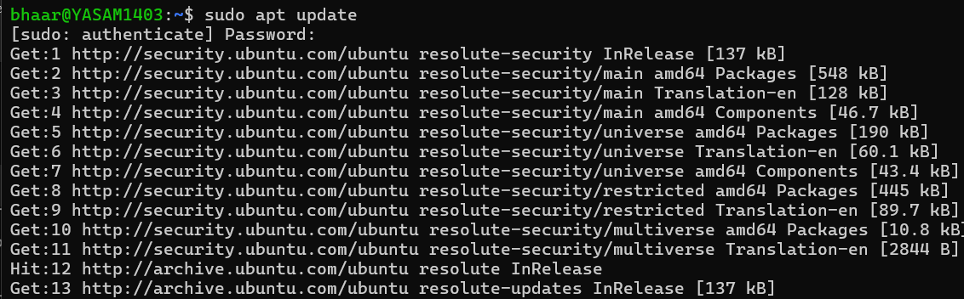
Step 2
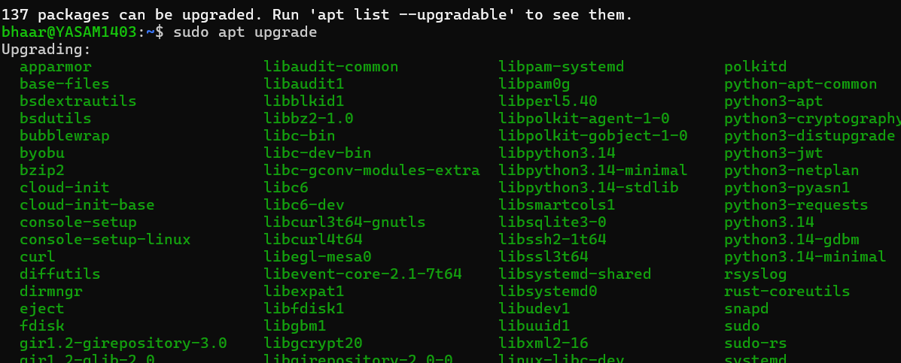
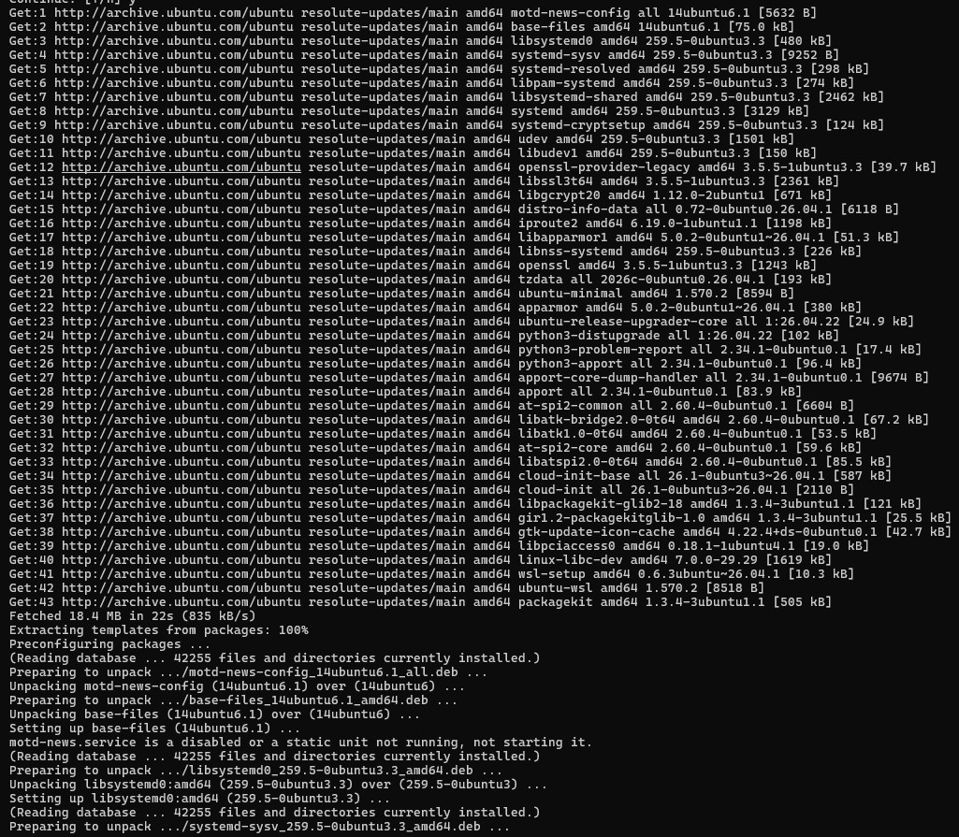
Step 3
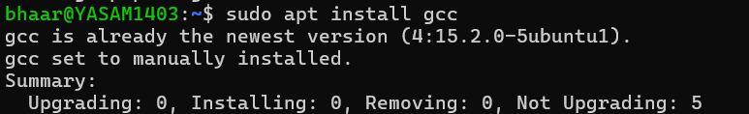
Step 4
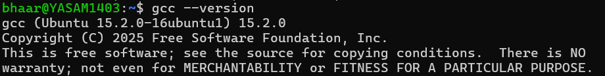

Step 5
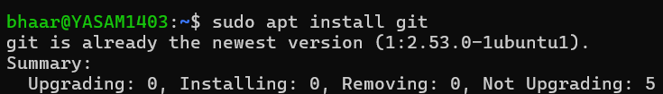
Step 6
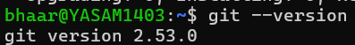
Step 7
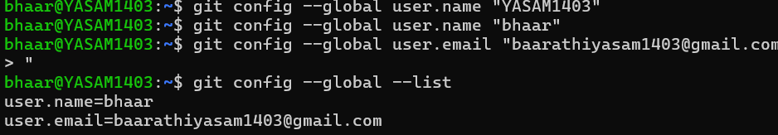
Step 8
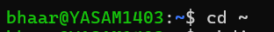
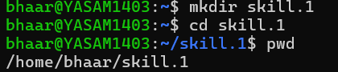
Step 9 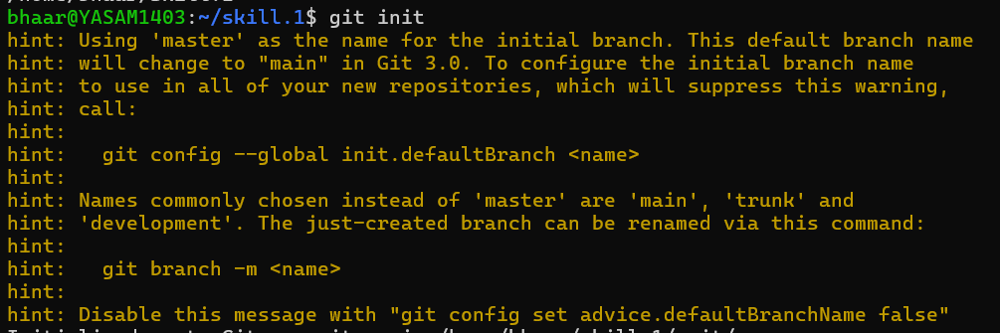

Step 10
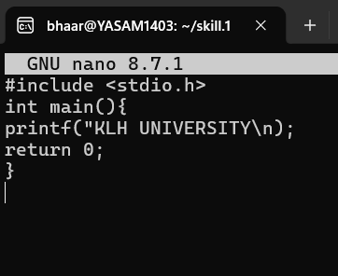
Step 11

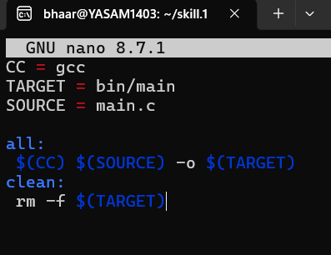
Step 12
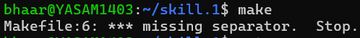
Step 13
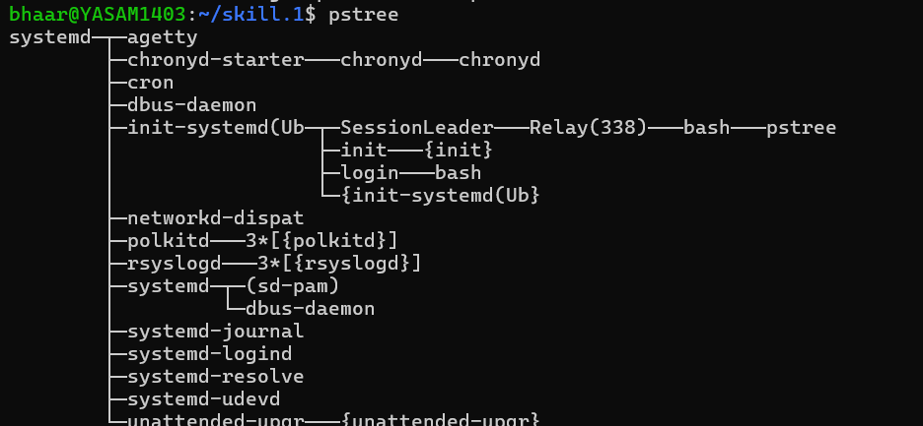

Conclusion
The Linux development environment was successfully configured with GCC, Git, project structure, and an initial Makefile. The experiment provided practical understanding of Linux shell architecture and process abstraction, including fork(), the exec() family, parent-child relationships, and process trees. System-call tracing using strace helped demonstrate how userlevel programs interact with the Linux kernel during process creation and execution.

